Name: GADDE TEJA SAI
Roll No: AP25110070720
Subject: Data structure
Assignment: Lab Task-5
GitHub Link: https://github.com/tejasaigadde
- Implementation of stack using array.
CODE:
#include <stdio.h>
#define MAX 100
int stack[MAX], top = -1;
void push(int x) {
if (top == MAX - 1)
printf("Stack Overflow\n");
else
stack[++top] = x;
}

void pop() {
if (top == -1)
printf("Stack Underflow\n");
else
printf("Popped element = %d\n", stack[top--]);
}

void display() {
if (top == -1)
printf("Stack Empty\n");
else {
for (int i = top; i >= 0; i--)
printf("%d ", stack[i]);
printf("\n");
}
}

int main() {
int ch, x;
while (1) {
printf("\n1.Push 2.Pop 3.Display 4.Exit\n");
scanf("%d", &ch);
switch (ch) {
case 1: scanf("%d", &x); push(x); break;
case 2: pop(); break;
case 3: display(); break;
case 4: return 0;
}
}
}
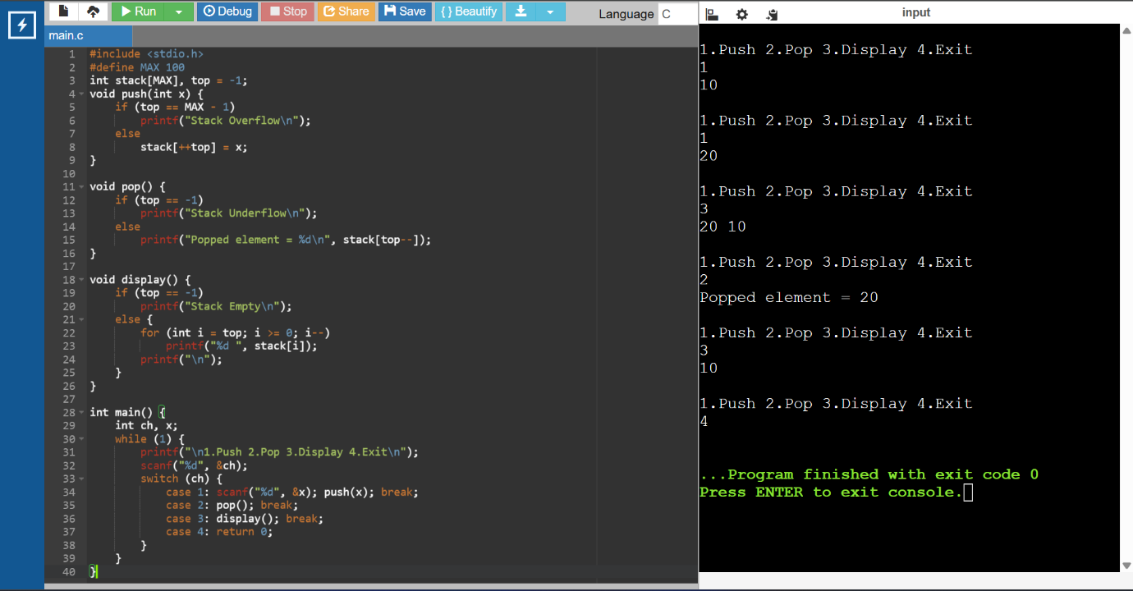

- A compiler front-end receives arithmetic expressions in infix form entered by programmers. To simplify expression evaluation, the compiler internally converts expressions into postfix form. Write a program to convert a given infix expression into postfix expression using stack.
CODE:
#include <stdio.h>
#include <ctype.h>
char stack[100];
int top = -1;
void push(char x) { stack[++top] = x; }
char pop() { return stack[top--]; }
char peek() { return stack[top]; }
int priority(char x) {
if (x == '+' || x == '-') return 1;
if (x == '*' || x == '/') return 2;
return 0;
}
int main() {
char exp[100], postfix[100];
int i, j = 0;
printf("Enter infix expression: ");
scanf("%s", exp);
for (i = 0; exp[i]; i++) {
if (isalnum(exp[i]))
postfix[j++] = exp[i];
else if (exp[i] == '(')
push(exp[i]);
else if (exp[i] == ')') {
while (peek() != '(')
postfix[j++] = pop();
pop();
}
else {
while (top != -1 && priority(peek()) >= priority(exp[i]))
postfix[j++] = pop();
push(exp[i]);
}
}

while (top != -1)
postfix[j++] = pop();
postfix[j] = '\0';
printf("Postfix = %s", postfix);
}
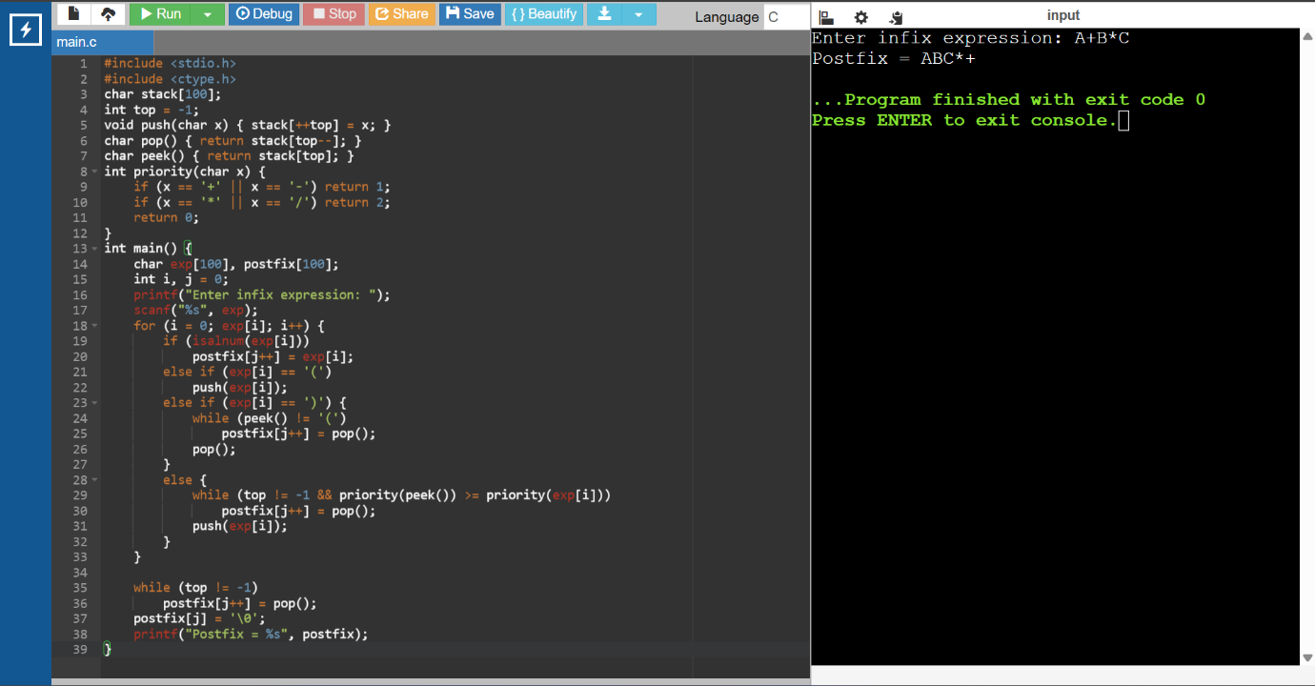

- An Integrated Development Environment (IDE) needs to validate and convert arithmetic expressions written by students. Write a program to convert an infix expression to postfix and display an error message if parentheses are mismatched.
CODE:
#include <stdio.h>
#include <ctype.h>
char stack[100];
int top = -1;
void push(char x) { stack[++top] = x; }
char pop() { return stack[top--]; }
char peek() { return stack[top]; }
int priority(char x) {
if (x=='+'||x=='-') return 1;
if (x=='*'||x=='/') return 2;
return 0;}
int main() {
char exp[100], postfix[100];
int i, j = 0;
printf("Enter infix expression: ");
scanf("%s", exp);
for (i=0; exp[i]; i++) {
if (isalnum(exp[i]))
postfix[j++] = exp[i];
else if (exp[i]=='(')
push(exp[i]);
else if (exp[i]==')') {
while (top!=-1 && peek()!='(')
postfix[j++] = pop();
if (top==-1) {
printf("Error: Mismatched Parentheses\n");
return 0;}
pop();}
else {
while (top!=-1 && priority(peek())>=priority(exp[i]))
postfix[j++] = pop();
push(exp[i]);}
}
while (top!=-1) {
if (peek()=='(') {
printf("Error: Mismatched Parentheses\n");
return 0;}
postfix[j++] = pop(); }
postfix[j]='\0';
printf("Postfix = %s", postfix);}
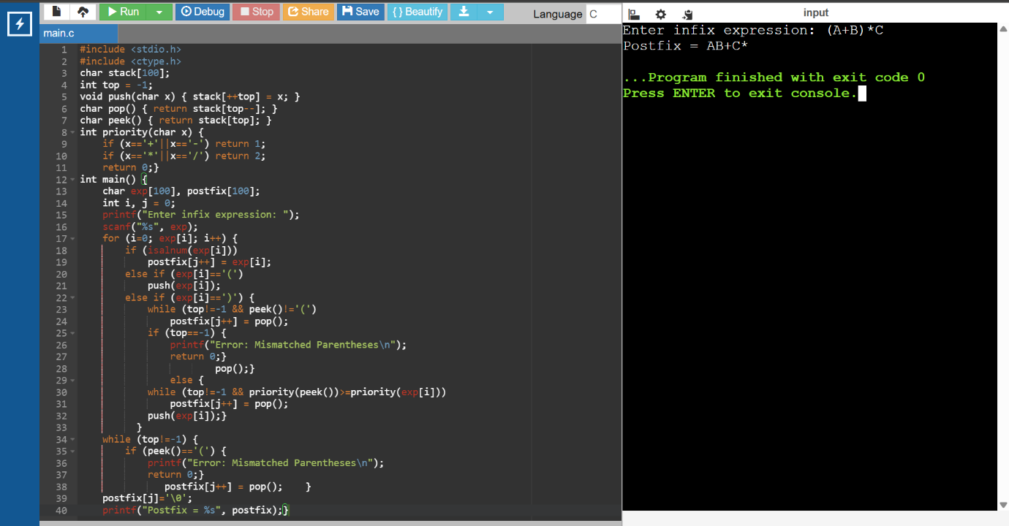

- A calculator application internally stores arithmetic expressions in postfix format for faster evaluation. Write a program to evaluate a given postfix expression using a stack.
CODE:
#include <stdio.h>
#include <ctype.h>

int stack[100], top = -1;

void push(int x) { stack[++top] = x; }
int pop() { return stack[top--]; }

int main() {
char postfix[100];
int i, a, b;

printf("Enter postfix expression: ");
scanf("%s", postfix);

for (i=0; postfix[i]; i++) {
if (isdigit(postfix[i]))
push(postfix[i] - '0');
else {
b = pop();
a = pop();

switch(postfix[i]) {
case '+': push(a+b); break;
case '-': push(a-b); break;
case '*': push(a*b); break;
case '/': push(a/b); break;
}
}
}

printf("Result = %d", pop());
}
